Phase 4
Project Planning Phase

Phase 4: Project Planning Phase

Entity-Relationship (ER) Diagram Description

The AI StudyBuddy backend manages data through interconnected MongoDB collections that store user information, study materials, and AI-generated learning resources. Each entity is linked using logical relationships to ensure efficient data management and retrieval.



User Entity

Stores the details of registered users and administrators.

Attributes:

_id (Primary Key - ObjectId)

name (String, Required)

email (String, Required, Unique)

password (String, Hashed)

role (String - Student/Admin)

createdAt

Study Material Entity

Stores study content uploaded by students for AI processing. Attributes:

_id (Primary Key)

userId (Foreign Key → User)

title

subject

content

createdAt

Summary Entity

Stores AI-generated summaries.

Attributes:

_id (Primary Key)

userId (Foreign Key → User)

materialId (Foreign Key → Study Material)

summary

createdAt

Flashcard Entity

Stores AI-generated flashcards.

Attributes:

_id (Primary Key)

userId (Foreign Key → User)

materialId (Foreign Key → Study Material)

question

answer

createdAt

Quiz Entity

Stores AI-generated quizzes.

Attributes:

_id (Primary Key)

userId (Foreign Key → User)

materialId (Foreign Key → Study Material)

questions

createdAt

6. Study Plan Entity

Stores personalized study plans generated by AI.

Attributes:

_id (Primary Key)

userId (Foreign Key → User)

studyPlan

examDate

createdAt

Key Structural Mappings

User → Study Material (One-to-Many): A user can upload multiple study materials.

Study Material → Summary (One-to-One): Each uploaded material can have one AI-generated summary.

Study Material → Flashcards (One-to-Many): One study material can generate multiple flashcards.

Study Material → Quiz (One-to-One): One study material can generate one quiz containing multiple questions.

User → Study Plan (One-to-Many): A user can generate multiple study plans based on different subjects or examination schedules.

User → AI Resources (One-to-Many): All AI-generated summaries, flashcards, quizzes, and study plans are associated with the user who generated them.

Key Features
The AI StudyBuddy backend provides intelligent learning assistance through secure and scalable REST APIs. The major features of the system are as follows:
- Secure User Authentication: Implements JWT-based authentication with encrypted passwords using bcrypt for secure user access.
- Study Material Management: Allows users to upload and manage study materials that serve as input for AI-powered learning features.
- AI Summary Generation: Generates concise and easy-to-understand summaries from uploaded study content using the Google Gemini API.
- AI Flashcard Generation: Automatically creates flashcards from study materials to improve concept revision and active recall.
- AI Quiz Generation: Produces multiple-choice quizzes based on uploaded content, enabling students to test their knowledge.
- AI Study Plan Generation: Generates personalized study plans according to the user's learning goals and available study time.
- Role-Based Access Control (RBAC): Provides different access privileges for Students and Administrators to ensure secure system management.
- MongoDB Data Storage: Efficiently stores user information, uploaded materials, and AI-generated learning resources using MongoDB.

Roles and Responsibilities

Student

Students are the primary users of the system. They can register, log in securely, upload study materials, and utilize AI-powered features such as summary generation, flashcard creation, quiz generation, and personalized study plans.

Administrator

Administrators manage the overall system and ensure its smooth operation. They monitor registered users, manage user accounts, oversee application usage, maintain system integrity, and ensure that AI-powered services function correctly. Administrators also have permission to perform system-level management tasks and resolve user-related issues.

User Flow

The AI StudyBuddy application begins with the user registering or logging into the system. After successful JWT-based authentication, the user is redirected to the dashboard, where they can upload study materials and access AI-powered features. Based on the uploaded content, the system generates summaries, flashcards, quizzes, or personalized study plans using the Google Gemini API. All generated resources are displayed to the user and can be saved for future reference. Users can also manage their profile and view their previously generated learning resources through the dashboard.

User Flow:
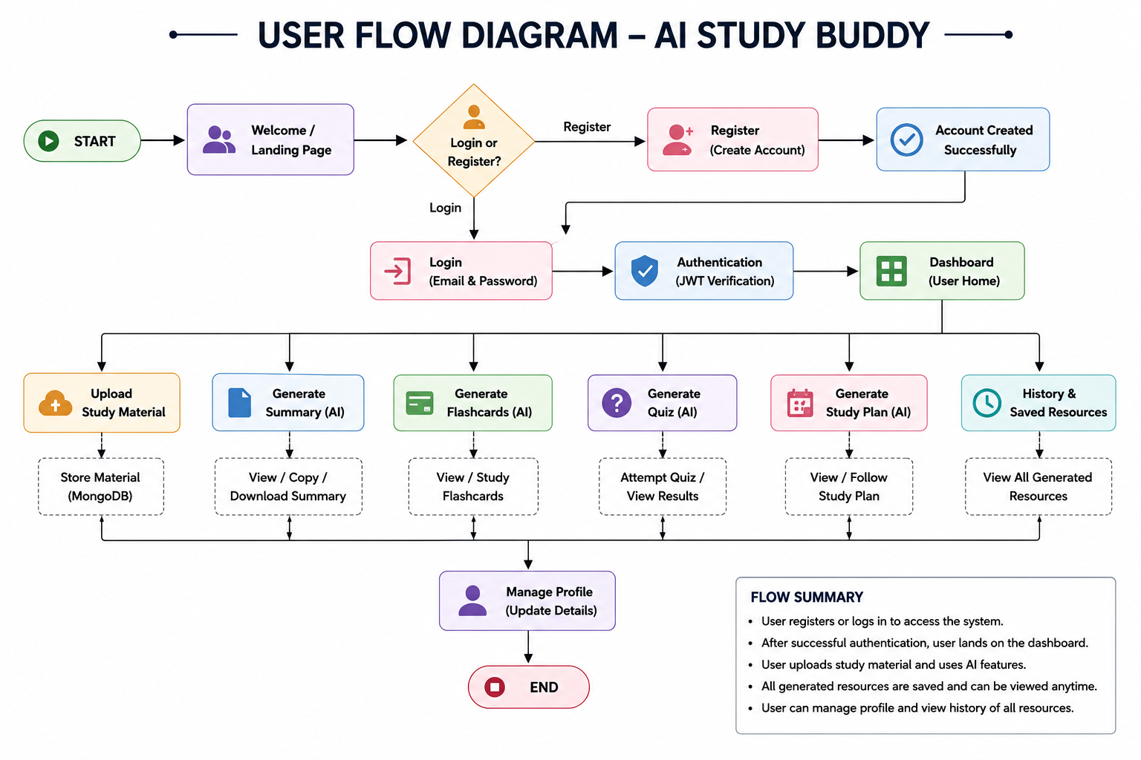

MVC Architecture Pattern
The AI StudyBuddy backend follows the Model-View-Controller (MVC) architecture to organize the application into separate layers, making the code modular, maintainable, and scalable.

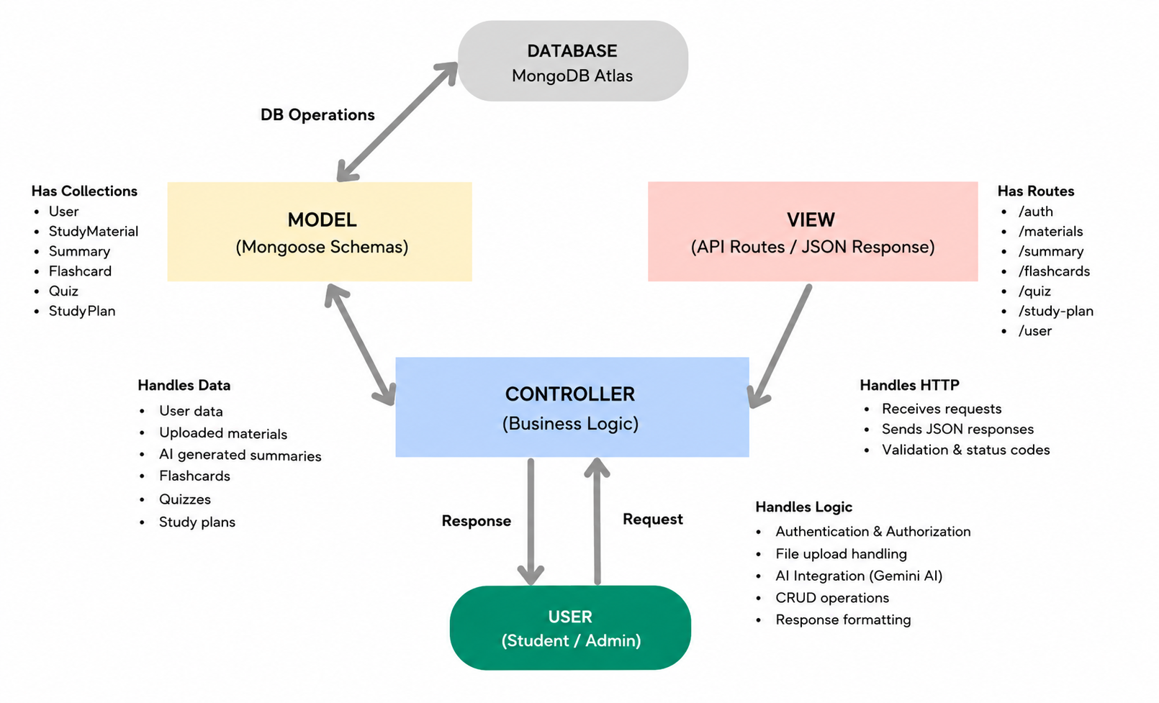

Model Layer (Data Layer)
The Model layer defines the MongoDB collections using Mongoose schemas. It is responsible for managing user information, uploaded study materials, and AI-generated learning resources while ensuring data validation and database interactions.

View Layer (API Response Layer)
Since AI StudyBuddy is a backend REST API, there is no traditional user interface in the View layer. Instead, the API returns structured JSON responses to the React frontend, allowing users to interact with the application through REST endpoints.
Controller Layer (Business Logic)

MVC Benefits
The MVC architecture separates data management, business logic, and client communication into independent components. This improves code readability, simplifies debugging and testing, and allows new features to be integrated without affecting existing modules.

